INGLÊS IV – BANCO DE DADOS

Class Didactic Material

Profa. Teresinha de Fátima Nogueira

Class 1 - Content – Past experiences

Objective - Talking about past experiences.

Problem 1:You are with some friends and each one has to tell a story about a past experience. Here are some topics to help you to prepare your story or you can choose another one. (2,0 pontos)



(from <https://www.istockphoto.com/br/search/2/image-film?phrase=people+talking>)

**1 – Travel adventure**: share a memorable travel experience, discussing the destination, the people you met, and any unexpected events.

**2 – Education**: talk about a significant learning experience that had an impact on you.

**3 – Career**: reflect on a particular project or achievement that stands out in your professional life.

**4 – Family memories**: discuss any family traditions or rituals that are special to you.

**5 – Personal growth**: discuss a moment in your life that marked a turning point in your personal growth and development.

**6 – Friendship stories**: discuss how certain friendships have influenced your life and shaped your perspective.

**7 – Hobbies and interests**: share any unique experiences related to your hobbies or interests.

**8 – Cultural experience**: discuss experiences that exposed you to different cultures or ways of life.

**9 – Adventure**: share humorous or adventurous stories from your past, focusing on the unexpected and the lessons learned.

**10 – Life lessons**: share advice or wisdom gained through your journey that may resonate with others.

1 – Watching a video: watch the video that follows to learn how to make a story and take notes.

<https://www.youtube.com/watch?v=T_qLKu0rFlU>

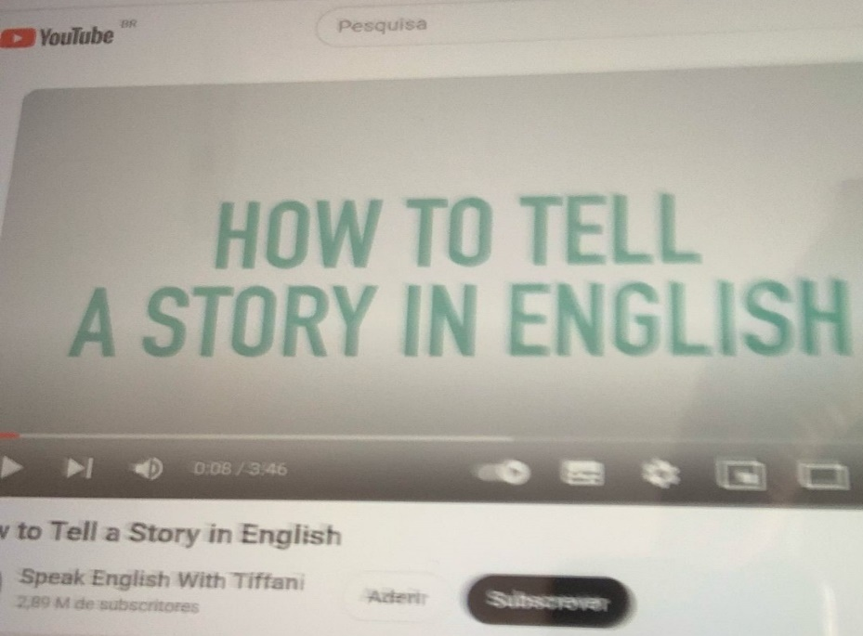

Class 2 - Content – Past experiences

Objective - Talking about past experiences.

2 – Language structure – simple past of regular verbs

To learn about the simple past of regular verbs you can study the explanation that follows, check understanding with your teacher, watch the following video or search for other materials on the Internet.

<https://www.youtube.com/watch?v=ZWZ6cNq6bEY> (past regular verbs)

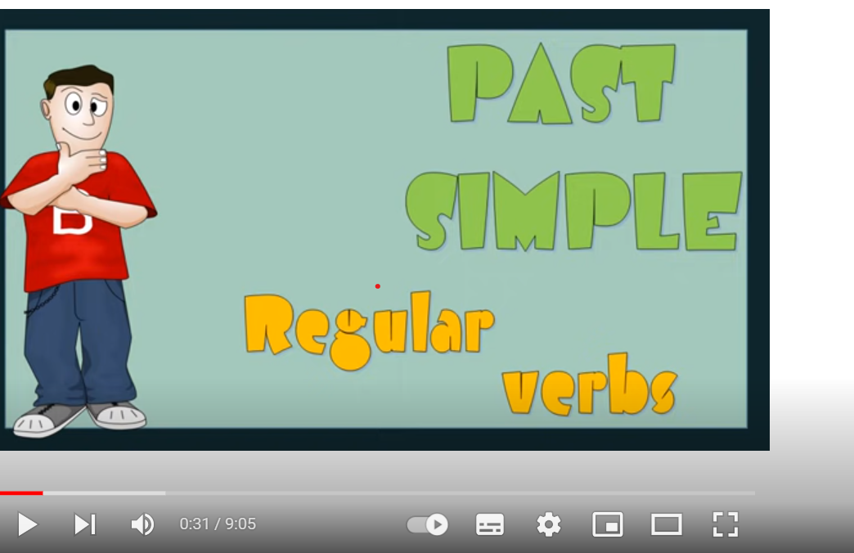

**SIMPLE PAST TENSE – REGULAR VERBS**

|  |  |  |
| --- | --- | --- |
| POSITIVE SENTENCES | | |
| SUBJECT | VERB | COMPLEMENT |
| I  You  We  They | WORKED | in a big company last year. |
| He  She  It | VISITED | a friend yesterday. |

|  |  |  |  |
| --- | --- | --- | --- |
| INTERROGATIVE SENTENCES | | | |
| AUXILIAR VERB | SUBJECT | VERB | COMPLEMENT |
| DID | I  You  We  They | WORK | in a big company last year? |
| DID | He  She  It | VISIT | a friend yesterday? |

|  |  |  |  |
| --- | --- | --- | --- |
| NEGATIVE SENTENCES | | | |
| SUBJECT | AUXILIAR VERB + NOT | VERB | COMPLEMENT |
| I  You  We  They | DID NOT / DIDN’T | WORK | in a big company last year. |
| He  She  It | DID NOT / DIDN’T | VISIT | a friend yesterday |

|  |  |
| --- | --- |
| SPELLING RULES | |
| VERBS | EXAMPLES |
| Most of the verbs, add ED | listen – listenED  play - playED |
| Ending in ‘E’, add “D” | live – liveD |
| Ending in consonant + “Y”, change “Y” to “I” and add “ED” | try – trIED  study - studIED |
| One syllable verb ending in consonant + vowel + consonant, double the last consonant and add ED | Stop - stoPPED |

Class 3 - Content – Past experiences

Objective - Talking about past experiences.

|  |  |  |
| --- | --- | --- |
| ED PRONUNCIATION | | |
| ED = [t] | ED = [d] | ED = [id] |
| (f) laugh – laughed  (p) help - helped  (k) work - worked  (sh) wash - washed  (ch) watch - watched  (s) dance - danced | call – called  clean – cleaned  offer – offered  phone – phoned  play - played | (t) want - wanted  (d) need - needed |

3 - Exercises: to train the different pronunciation of “ED” endings, you can do these exercises.

3.1 - Listen and repeat the verbs. (American English File 1, p.55)



|  |  |  |
| --- | --- | --- |
| -ED = [d] | -ED = [t] | -ED = [id] |
| CALLED | LOOKED | WANTED |
| ARRIVED | RELAXED | CHATTED |
| LISTENED | STOPPED | TEXTED |

3.2 - Do the proposed pronunciation activities.

<https://www.englisch-hilfen.de/en/exercises/pronunciation1/index.php>

<https://www.englishmaven.org/HP6/Pronouncing%20ED%20Endings%20Exercise%203.htm>

3.3 - Do these online grammar exercises.

<https://www.englisch-hilfen.de/en/exercises/tenses/simple_past_statements.htm>

<https://elt.oup.com/student/solutions/elementary/grammar/grammar_06_022e?cc=br&selLanguage=pt>

<https://firstenglish.org/english_learning/english_tenses/simple_past/2/55_english_questions_exercises.htm>

<https://www.tolearnenglish.com/exercises/exercise-english-2/exercise-english-6036.php>

Class 4 - Content – Past experiences

Objective - Talking about past experiences.

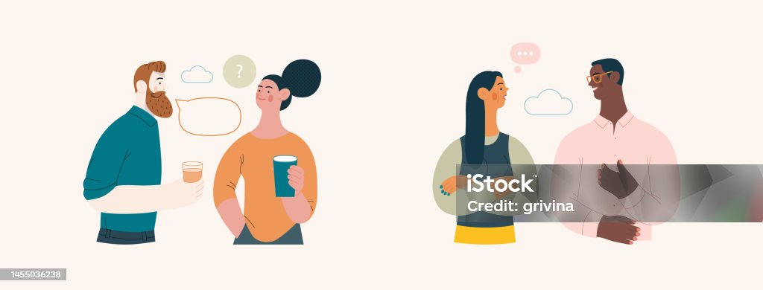

(from <https://www.istockphoto.com/br/vetor/retratos-de-pessoas-pessoas-falantes>)

4 – Speaking - Ask and answer these questions:

1-When was the last time you used a GPS? Why?

2-When was the last time you watched a film or series? Which one?

3-When was the last time you chatted online? Who with?

4-When was the last time you arrived late for class? Why?

5-When was the last time you played a computer game? Which one?

6-When was the last time you travelled to a beach city? Which one?

7-When was the last time you played a sport? What sport?

8-When was the last time you called a friend? Who?

9-When was the last time you laughed really hard? What was so funny?

10-When was the last time you helped someone? How did you help the person?

11-Who did you visit last week?

12-When did you start learning English?

13-Where did you study in high school?

14-What music did you listen to this morning?

15-What series did you watch last Saturday?

16-Who did you text to this morning?

**17-Where did you live when you were a child?**

**5- Listening: Listen to the following two dialogues and write down what were the problems and how they solved them.**

<https://www.linguahouse.com/esl-lesson-plans/business-english/problem-solving/audioplayer/problem-solving-ex3>

Dialogue 1:

________________________________________________________________________________________________________________________________________________________________________________________________________________________________________________________________________________________

Dialogue 2:

________________________________________________________________________________________________________________________________________________________________________________________________________________________________________________________________________________________

Class 5 - Content – Past experiences

Objective - Talking about past experiences.

6 – Language structure – simple past of irregular verbs: To learn about the simple past of irregular verbs you can study the explanation that follows, check understanding with your teacher, watch the videos that follow, or you can search for other materials on the Internet.

<https://www.youtube.com/watch?v=NYDkHBomOU8>

<https://www.youtube.com/watch?v=gK12tjcqpsM> (list of many irregular verbs)

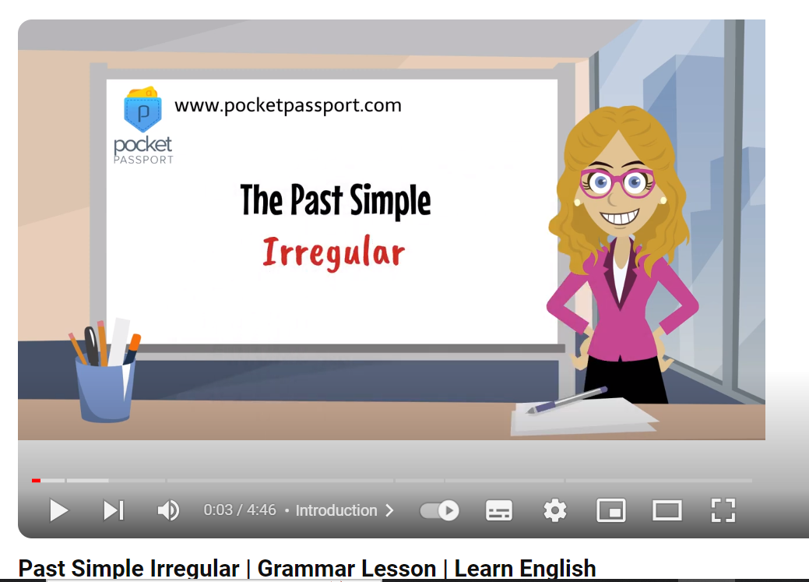

**SIMPLE PAST TENSE – IRREGULAR VERBS**

|  |  |  |
| --- | --- | --- |
| POSITIVE SENTENCES | | |
| SUBJECT | VERB | COMPLEMENT |
| I  You  We  They | WENT | to the beach last summer. |
| He  She  It | SAW | a good film yesterday. |

|  |  |  |  |
| --- | --- | --- | --- |
| INTERROGATIVE SENTENCES | | | |
| AUXILIAR VERB | SUBJECT | VERB | COMPLEMENT |
| DID | I  You  We  They | GO | to the beach last summer? |
| DID | He  She  It | SEE | a good film yesterday? |

|  |  |  |  |
| --- | --- | --- | --- |
| NEGATIVE SENTENCES | | | |
| SUBJECT | AUXILIAR VERB + NOT | VERB | COMPLEMENT |
| I  You  We  They | DID NOT / DIDN’T | GO | to the beach last summer. |
| He  She  It | DID NOT / DIDN’T | SEE | a good film yesterday |

Class 6 - Content – Past experiences

Objective - Talking about past experiences.

7 – Exercises – Do the following exercises:

7.1 - Complete the text with the verbs in parentheses in the simple past. (from American English File 1, page 137)

Last weekend, I _______________ (go) to New York City with some friends. We __________________ (meet) at the train station at 7:30 a.m. Our train ______________ (leave) at 7:45 a.m. In the morning, we __________________ (buy) some souvenirs. Then, we ________________ (have) lunch at a Chinese restaurant. In the evening, we _________________ (see) a play at Lincoln Center. We ________________ (get) home very late that night. We all ________________ (feel) very tired but very happy.

7.2 – Do these online exercises:

<https://www.perfect-english-grammar.com/irregular-verbs-exercise-1.html>

<http://www.quiz-tree.com/ESL-Grammar_Irregular-English-Verbs---Simple-Past_1imageXML.html?subjPage=ESL_Grammar_main&tableID=7>

<https://elt.oup.com/student/solutions/elementary/grammar/grammar_07_012e?cc=br&selLanguage=pt>

Class 7 - Content – Past experiences

Objective - Talking about past experiences.



(from <https://unsplash.com/pt-br/fotografias/>)

8 – Listening - You are going to listen to David from Spain talking about his memorable night. (from American English File 1, OUP, page 57). Listen and answer these questions:



1– When was his memorable night?

_____________________________________________________________________

2– Why did he remember the date?

____________________________________________________________________

3– Where was he?

____________________________________________________________________

4– Where did he go to watch the match?

___________________________________________________________________

5– What did he wear?

____________________________________________________________________

6– What time did he get back to the hotel?

___________________________________________________________________

7– Why was the night memorable?

___________________________________________________________________

Class 8 - Content – Past experiences

Objective - Talking about past experiences.



(<https://www.freepik.com/free-photos-vectors/people-talking>)

9 - Speaking - Ask and answer these questions.

1-Who was your hero when you were young?

2-Did you have a pet when you were younger? Which one?

3-Who were some of your favourite sports stars in the past? What did they play? Why were they your favourite?

4-What did you do for your last birthday?

5-Tell me about where you lived when you were a child.

**6-Tell me about what you did for the last 24 hours.**

7-Who had the biggest impact on the person you have become? Why?

8-What time did you get up yesterday?

9-How many hours did you sleep last night?

10-Where did you have lunch last Saturday?

11-Where did you go Friday night?

12-How did you come to class today?

13-Who did you have lunch with today?

14-What did you drink in your breakfast this morning?

15-How much time did you spend on WhatsApp yesterday?

16-What series did you see last month?

17-How many emails did you get yesterday?

18-What did you do Sunday afternoon?

19-What did you last thank someone for?

Class 9 - Content – Past experiences

Objective - Talking about past experiences.



(from <https://www.freepik.com/free-photos-vectors/students-studying>)

10- Speaking – Prepare the short story suggested in problem 1.

Class 10 - Content – Past experiences

Objective - Talking about past experiences.

11- Speaking – Prepare the short story suggested in problem 1.

Class 11 - Content – Past experience

Objective - Talking about past experiences.



(from <https://www.freepik.com/free-photos-vectors/student-presentation>)

12- Dialogue – Presentation of the short story suggested in problem 1. (2,0 pontos)

Class 12 - Content – Past experience

Objective - Talking about past experiences.

13- Dialogue – Presentation of the short story suggested in problem 1. (2,0 pontos)